**A’ LEVEL BIOLOGY DISCUSSION**

**EVOLUTION AND GENETICS**

1. The figure below shows the variation of number of peppered moths before and during the industrial revolution in UK.

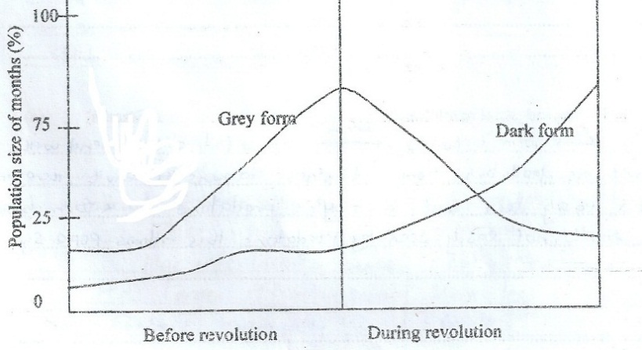

1. Describe the changes in the population of both peppered of moths.

(i) Before industrial revolution (1½mks) (ii) During industrial revolution (1½mks)

1. Account for the changes in the population of the peppered moths

(i) Before industrials revolution (3mks)

(ii) During industrial revolution. (3mks)

1. What form of natural selection is being represented in the graph in the period of industrial revolution (1mk)
2. (a) In bred strains of animals such as mice are usually preferred in experiments such as testing the effect of new drugs.
   1. What is meant by ‘In-bred’ strains? (1mk)
   2. What advantages do investigators derive from the use of ‘In – bred’ strains (2mks)

(b) State three consequences of inbreeding in wild life populations. (3mks)

(c) In cattle, colour fur and its distribution are determined by two genes that are **not** linked. A red and spotted fur cow was mated with a uniform black fur bull. All the F1 offspring had uniform black fur. The F1 offspring were crossed. Determine using genetic crosses the phenotypic ratio of the offspring after a test cross. (5mks)

1. (a) Define the following terms. (1mk@)

(i) Genetic equilibrium (ii) Genetic load (iii) Genetic death

(b) Give any four factors which can disrupt the genetic equilibrium of a sexually reproducing population of organisms (2mks)

(c) Some people can roll their tongue while others cannot. The allele for tongue rolling is dominant to that of the non – rollers. The percentage of all tongue rollers is 71.2%.

1. What is the percentage of the non – rollers? (1mk)
2. What is the probability of an individual in a population being heterozygous for tongue rolling? Show your working. (3mks)
3. Calculate the genotype frequency of heterozygous individuals for tongue rolling. (1mk)
4. (a) Briefly describe the meaning of the following.
   1. Deme (ii) gene pool (iii) allele frequency (1mk@)

(b) Briefly explain the Hardy – Weinberg principle. (4mks)

(c) List the assumptions made in deriving the Hardy – Weinberg equation. (3mks)

1. (a) What do you understand by the terms? (2mks)
   1. Sex linked genes
   2. Sex limited genes

(b) (i) In Drosophila, the gene for wing length and for eye colour are sex linked. Normal wing and red eye are dominant to miniature wing and white eye. In a cross between a miniature wing, red eyed male and homozygous normal wing white eyed, using genetic crossing, determine the phenotypic ratio of F2 generation. (4mks)

(i) Assuming that no crossing took place, determine the phenotypes of F2 generation (4mks)

1. (a)Humans possess one of the following blood groups A,B,AB and O. Describe these phenotypes in terms of;
   1. The constituents of the red blood cell membranes (4mks)
   2. The plasma antibodies.
   3. Their possible genotypes.

(b) Erminette fowls are characterized by possessing light coloured feathers with occasional black ones, giving them a flecked appearance. A cross between two erminettes produced a total of 48 progeny consisting of 22 erminettes, 14 blacks and 12 white fowls.

1. Using these results, suggest s genetic basis for the erminette pattern in the fowls. (2mks)
2. Construct a genetic diagram of a cross to show how the erminatte pattern is inherited in fowls.

(4mks)

1. (a) What is meant by the term ***extinction*?** (1mk)

(b) State one natural cause of extinction (1mk)

(c) Mention the ways in which human activity has accelerated the rate of extinction in present times. (3mks)

(d) Suggest three measures that can be put in place to prevent extinction of species. (3mks)

(e) Explain why large predators such as birds of prey are more prone to extinction that herbivores (2mks)

1. (a) The graph below shows precipitation of serum, when human serum is mixed with different serum of different animals and precipitates are compared. Use it to answer the questions below it.

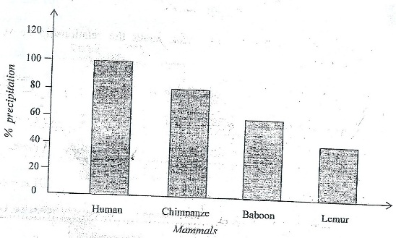

* 1. Describe the trend of precipitation from human to lemur. (2mks)
  2. Explain how precipitation is formed when sensitized rabbit serum is mixed with any mammal’s serum (3mks)

(b) Explain the difference in the amount of precipitation formed between chimpanzee and man (2mks)

(c) State **one** evolutionary conclusion about the relationship between human being and

(i) Chimpanzee (ii) Lemur (2mks)

1. (a) Describe the evidence of evolution based on palaeontology. (9mks)

(b)Explain how the following may lead to evolution of a new species;

1. Selective breeding (5mks)
2. Increased population size (6mks)
3. The information below was collected by a Geneticist concerning the number of individuals withtheir corresponding heights in a given population.

|  |  |  |  |  |  |  |  |  |  |
| --- | --- | --- | --- | --- | --- | --- | --- | --- | --- |
| **Number of individuals (‘0000)** | 1.5 | 2.2 | 5.0 | 9.0 | 16.0 | 22.0 | 14.0 | 4.0 | 3.0 |
| **Height (cm**) | 155 | 160 | 167 | 170 | 173 | 176 | 185 | 191 | 195 |

(a) Using the information provided plot a graph of the number of individuals (‘000) against their height. (5mks)

(b) From the graph, determine the number of individuals measuring **180.00**cm in height. (1mk)

(c) (i) Which type of variation is exhibited by the individuals regarding the character in question? (1mk)

(ii) Apart from height, give four other characters that show similar behavior in man (2mks)

(iii) State four properties of the characters you have mentioned above (2mks)

1. (a) Variation can be due to environmental or genetic factors. Describe how both sources can lead to speciation and evolution. (10mks)

(b) How has man made use of his knowledge of variation and evolution to his benefit? (10mks)

1. (a) Describe the different forms of isolation and how they lead to speciation (10mks)

(b) Briefly describe the theories evolution (10mks)

1. (a) Explain the role played by the following in the process of speciation (12mks)

(i) Natural selection (ii) Polyploidy (iii) Reproductive isolation

(b) If there were no fossils, what evidence would there have been for evolution (8mks)

1. (a) Variation can be due to environmental or genetic factors. Describe how sources of variation could contribute to speciation and evolution (12mks)

(b) How has man made use of his knowledge of variation to his benefit? (8mks)

1. (a) State Darwin’s theory of evolution and use it to account for the existence of two Fauna on Galapagos island

(10mks)

(b) State the major differences between Darwin and Lamarck’s theories of evolution (6mks)

(c) Give four examples which indicate that evolution is still taking place (4mks)

1. (a) What may cause the genetic constitution of an organism to change? (4mks)

(b) State the different ways in mutation may occur (4mks)

(c) Cystic fibrosis of the lungs is known to persist in a population for long. Using illustrations, explain how this occurs for two successive generations (12mks)

(d) Why does an individual suffering from sickle cell anaemia face early death? (6mks)

1. (a) Describe how abnormal haemoglobin arises in human population. (9mks)

(b) Explain;

1. the effect of the gene for abnormal haemoglobin in the human population. (7mks)
2. Why people with the sickle cell trait do not suffer from malaria? (6mks)
3. (a) Explain the main features of Darwin’s theory of evolution. (12mks)

(b) The bettles belonging to the genus *Colophon* are unable to fly and are found on hilltops following statements.

1. All of these bettles are of very similar general appearance. (2mks)
2. There are slight differences between the species of *Colophon* found in the three areas. (3mks).
3. The fact that the bettles of the genus *Colophon* are unable to fly has been important in the evolution of twelve different species of the genus in a small area of South Africa. (3mks)
4. (a) Define the following terms
5. Mutation (2mks)
6. Non disjunction (2mks)

(b) List four types of mutagens (2mks)

(c) Briefly explain how sickle cell anaemia genetically arises. (3mks)

(d) Mention one advantage of the sickle cell gene. (1mk)

1. In an oil seed plant species, the allele for tallness is dominant over that for dwarfness. Meanwhile the allele for chlorophyll production and non-chlorophyll show incomplete dominance. The heterozygous plants are variegated.
2. Using suitable symbols, construct a diagram of a cross between a heterozygous tall plant with green leaves and a dwarf plant with variegated leaves, to show the genotypes of the off-springs.
3. Explain why 25% of the off-springs of the cross in (a) would fail to survive.
4. (a) What is meant by genetic recombination? (3mks)

(b) What is the importance of genetic recombination in the process of evolution? (2mks)

(c) What limits the degree of recombination in animal populations? (5mks)

1. (a)Describe how species arise according to Darwin’s theory. (7mks)

(b) Explain how each of the following can affect the gene frequency within a population.

(i) Biased mating. (3mks) (ii) Disruptive selection. (5mks) (iii) Mutation. (5mks)

1. Fossils were taken from a rocky mountain and the frequency of rodents and multi tuberculates recorded the table of results shown below. The animals are similar and have gnawing teeth but rodents have only two front teeth whereas multiberculates have many.

|  |  |  |
| --- | --- | --- |
| **Millions of year ago** | **Rodent species** | **Multituberculates species** |
| 45 | 31 | 0 |
| 50 | 19 | 0 |
| 55 | 12 | 5 |
| 60 | 1 | 11 |
| 65 | 0 | 19 |
| 70 | 0 | 7 |

1. Why did the biologist choose a rocky mountain area for the fossil study? (1mk)
2. State two ways in which fossils man be formed (2mks)
3. What conclusion can you draw from the data above? (3mks)
4. (i) Explain the term adaptive radiation (1mk)

(ii) Explain how the principle of adaptive radiation led to the survival of the Australian founa. (3mks)

1. (a) what is meant by the following term
   1. Allele (1mk)
   2. Codominance (1mk)

(b) In cats the allelic gene for black colour and ginger colour are co-dominant where the heterozygote possess a tortoise shell coat colour are sex linked. Given that a male cat with ginger coat colour was crossed with a female black coat colour. Using genetic symbols work out the F1 and F2 offsprings. (8mks)

1. (a) Explain the significance of the following evolutionary study.
2. Comparative anatomy (7mks)
3. Comparative serology (3mks)

(b) How does the concept of development and distribution of Darwin’s finches at Galapagos Island explain evolution? (10mks)

1. (a) What is meant by the following terms

(i) Natural selection (3mks) (ii) Reproductive isolation (2mks) (iii) Polyploidy (2mks)

(b) Explain the role played by each of the phenomena in (a) above in the evolution of new species. (9mks)

(c) How may species become extinct? (4mks)

1. (a) Explain the main features of Darwin’s theory of evolution (12mks)

(b) The beetles belonging to the genus ***Colophon*** are unable to fly and are found on hilltops in three areas in South Africa. Suggest the evolutionary explanation for each of the following statements.

1. All these beetles are of very similar general appearance. (2mks)
2. There are slight differences between species of ***Colophon*** found in the three areas. (3mks)
3. The fact that the beetles of the genus ***Colophon*** are unable to fly has been important in the evolution of twelve different species of the genus in a small area of South Africa. (3mks)
4. (a) Describe the evidence of evolution based on palaeontology

(b) Explain how the following may lead to evolution of new species

(i) Selective breeding (5mks) (ii) Increased population size (6mks)

1. (a) Briefly describe the 5 theories of the origin of life. ( 2½ mks)

(b)Give an account of the evidence of evolution based on

(i) continental drift (5mks) (ii) industrial melanism (5 mks) (iii) species distribution ( 2½ mks)

(c) Briefly describe Darwinian evolution theory. (5 mks)

1. (a) (i) What do you understand by the term mutation.

(ii) Give an account of the process of mutation and its causes.

(b) State the role of mutation in evolution.

1. The table below show the variation of the frequency (%) of the two species of moths **A** and **B**, in a sampled area, with changes in the concentration of industrial effluents discharge in an area, mainly sulphur dioxide and soot.Study the table and answer the questions that follow.

|  |  |  |  |  |  |  |
| --- | --- | --- | --- | --- | --- | --- |
| Frequency of species **A** (%) | 0 | 0 | 2 | 20 | 220 | 443 |
| Frequency of species **B** (%) | 450 | 448 | 390 | 120 | 40 | 20 |
| Concentration of industrial effluents with time (ppm) | 0 | 0 | 10 | 30 | 90 | 120 |

1. Define the term industrial melanism. (1mk)
2. Comment on the relationship between the concentration of industrial effluents and the two species A and B (3mks)
3. Briefly explain the variation of the frequency of the two species A and B with the concentration of industrial effluents (5mks)
4. Suggest how species A could have come into existence in the sampled area. (1mk)
5. (a) Define the following terms (1mk@)
   1. Sympatric speciation
   2. Reproductive isolation

(b)When radish 2n= 18, was crossed with cabbage 2n=18, they produced infertile offspring. Account for such an observation. (2mks)

(c) Explain the possibility of new species formation from the above couple of radish and cabbage (3mks)

1. (a) What are sex limited characters? (2mks)

(b) Explain why sex linked characters are more common in males than females. (3mks)

(c) Although the frequency of the gene for abnormal haemoglobin in human population is low, that gene cannot completely disappear from the population. Explain that observation (3mks)

(d) What is meant by a pure line? (2mks)

1. (a) Describe the structure of a mature ovule  (5mks)

(b) Describe the development of a mature ovule. (11mks)

(c) What are the advantages of self-pollination? (4mks)

1. (a) (i) Define the term reproductive isolation (2mks)

(ii) Name any three causes of reproductive isolation in a population. (1½ mks)

(b) What is meant by natural selection? (2mks)

(c) What is the role of natural selection in evolution? (2mks)

(d) Polypoidy in plants is often associated with advantageous characteristics like great yields, resistance to diseases etc.

(i) What is meant by the term polyploidy? (2mks)

(ii)How does polyploidy occur. (2mks)

1. (a) What is a mutation? (1mk)

(b) What is the general name of the agents, which cause mutations? Give two examples of such agents.

(2mks) (c) What are the major categories of genetic mutations? (1mk)

(d) Name two common human diseases known to be caused by an inherited genetic mutation (1mk)

(e) Outline two areas of human activity where mutations being used for the benefit of human king (2mks)

1. In a genetic experiment, using the fruit fly ***Drosophilla melanogaster****, a* pure-breeding fly with **pink eyes** and short **wings** was crossed with another fly with **wild type eyes** and **long wings**. The F1 all had wild type eyes and long wings. The resulting F1 female fly were then crossed with their male parents and the resulting offspring were as follows;

|  |  |
| --- | --- |
| **Phenotype** | **Number of offsprings** |
| Pink eyes,short wings | **75** |
| Pink eyes,long wings | **78** |
| Wild type eyes,short wings | **76** |
| Wild type eyes,long wings | **77** |

(a) What name is given to the second mating/cross in the above experiment? (1mk)

(b) Using suitable symbols show how these results were obtained. (8mks) (c) What can you conclude about the location of the genes involved in the above experiment (1mk)

1. (a) Define the term euploidy.
2. Briefly explain why mutated genes cannot be eliminated from the populations of organisms.
3. Briefly explain the role of mutation towards evolution
4. Mention any two mutagens
5. (a) Mention any two reasons why Mendel chose to use *Pisum sativum*, in his experiments.
6. Manx cats do not have tails. When a Manx cat is mated with a normal long tailed cat, approximately half of the offsprings are long tailed and approximately half are Manx. When two Manx are mated, the ratio of offsprings is 2 Manx to 1 log tailed cat.
7. What does this suggest about the inheritance of the Manx condition in cats
8. Show by means of a cross, the inheritance of the Manx condition when two Manx cats are mated.
9. (a) Describe how abnormal haemoglobin arises in the human population.(5mks)

b) Explain the effects of the gene for abnormal haemoglobin in humans. (10mks)

c) What is meant by polyploidy?(5mks)

1. (a) Describe how a species may arise. (8mks)

(b) Outline the factors that lead to extinction of species. (8mks)

(c) Explain how human have benefited from their role in species formation. (4mks)

1. (a) Describe how the following serve as evidence for evolution
   1. Comparative anatomy
   2. Biochemistry
   3. Embryology
   4. Palaentology

(b) How do Darwin’s finches contribute towards the theory of evolution?

1. (a) Explain the following terms:
   1. Epistasis
   2. Incomplete dominance
   3. Genome
   4. Clone

(b) In white leghorn fowl plumage is controlled by two sets of genes. W(white) is dominant over w(colour). B(Black) is dominant over b(brown). The heterozygous genotype WwBb is white. Account for this type of interaction and show the phenotypic ratio in F2 generation.

1. (a) Explain the formation of the new cell wall, during the division of the parent cell, into daughter cells.

(b) Describe what happens during prophase 1 of meiosis.

(c) What is the significance of meiosis.

(d) Mention the events of meiosis of which results into genetic variation.

1. (a) Explain why identical twins reared apart are very useful in studies of inheritance? (2mks)

(b) A pure breeding fruit fly with a tan body and long wings was crossed with a mutant having a black body and short wings. The F1 all had tan bodies and long wings. The F2 was 75% tan with long wings and 25% black with short wings.

(i) Suggest an explanation for these results. (2mks)

(ii) Using a genetic diagrams show how these results were obtained. (6mks)

1. (a) What is meant by the term organic evolution? (1mk)

(b) Briefly explain how each of the following can be used to provide evidence for evolution.

1. Homologous organs. (3mks)
2. Development of vertebrate embryos. (3mks)
3. Industrial mechanism. (3mks)
4. (a) Describe how Darion explains evolution of a new species by natural selection. (10mks)

(b) Explain how the following may lead to evolution of a new species.

* 1. Selective breeding. (5mks)
  2. Increased population size. (5mks)

1. (a)Describe the main features of neo-Darwinism theory of evolution. (10mks)

b) Explain the evidence from the geographical distribution of organisms that supports the theory of evolution described in a) above. (10mks)

1. (a) What is the major hereditary material in living organisms? (1mk)

(b) What evidence is available to prove that the material named above is hereditary? (6mks)

(c) Describe the process by which information in the hereditary material is used to determine protein structure.

(13mks) 49. (a) Describe the causes of variation among individuals? (10mks)

(b) What are the conditions that favour Hardy-Weinberg Equilibrium to occur? (10mks)

1. In maize the genes for coloured seed and full seed are dominant to the genes for colourless seed and shrunken seed. Pure breeding strains of the dominant variety were crossed with the double recessive variety and a test cross of the F1 generation produced the following results.

Coloured, full seed 380

Colourless, shrunken seed 396

Coloured ,shrunken seed 14

Colourless , full seed 10

1. Explain the results in of the genetic experiment above. (5mks)
2. Calculate the recombination frequency. (3mks)
3. Explain the results in (b) above. (2mks)
4. (a) (i) What is meant by the term ‘natural selection’? (1mk)
5. Some years ago, it was thought that the use of antibiotics would result into total eradication of bacterial strains. However, bacteria are now more widely spread than ever and in forms more resistant to the antibiotics used. Explain the role of natural selection in the evolution of resistance to antibiotics in bacteria. (3mks)

(b) Night blind people have difficulty in seeing in dim light. The allele for night blindness, **n**, is recessive to the allele for normal vision, **N**. These alleles are not sex-linked. The diagram below shows part of a family tree showing inheritance of night blindness.

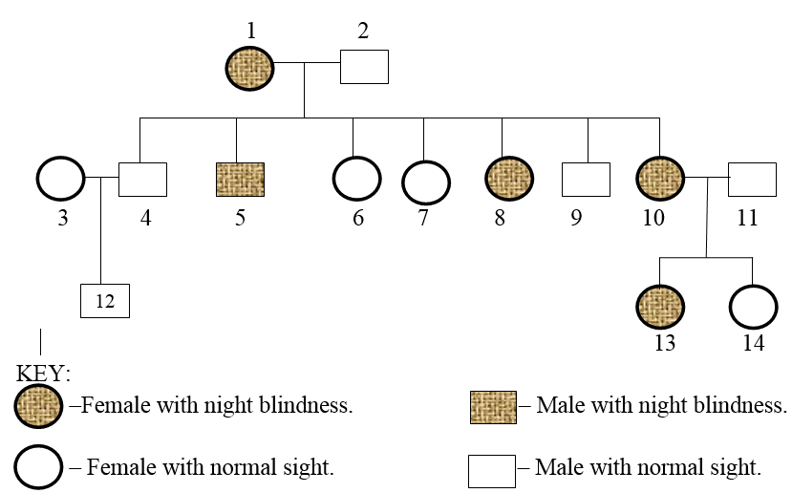

1. What is the most likely genotype of individual 2? Give reasons / evidence for your answer. (2mks)

(ii) What is the probability that the next child born to individuals 10 and 11 will be a girl with night blindness? Show your working. (2mks)

(iii) The cross between individuals 12and 14 would represent a mating between first cousins. Based on this, comment why a marriage between close relatives may be risky. (2mks)

1. (a) Give an outline of Darwin’s theory of evolution. (10mks)
2. Explain how each of the following supports Darwin’s theory of evolution;
3. industrial melanism (5mks)
4. resistance to insecticides (5mks)
5. (a) Derive the **Hardy-Weinberg** equation from first principles. (10mks)

(b) Describe how:

i) **Random mating**

ii) **Genetic drift**, affect the allele frequency of a sexually reproducing population.(10mks)

1. (a) In tomato the allele for yellow (W) is dominant to the allele for white flower (w) and the allele for red fruit (R) is dominant to the allele for yellow fruit (r). Plants with yellow flowers bear red fruit and those with white flowers bear yellow fruit. A cross between a plant with yellow flowers and red fruit and another with white flowers and yellow fruit gave F1 offspring with yellow flowers and red fruit. When F1 were selfed plants with the following combinations were determined.

39 plants with yellow flowers and red fruit

9 plants with yellow flowers and yellow fruit

9 plants with white flowers and red fruit

39 plants with white flowers and yellow fruit

Using the indicated symbols and appropriate diagrams show how the above results can be obtained (15mks)

(b) Calculate the cross over frequency of the above F2 generation (3mks)

(c) What biological phenomenon is illustrated by this experiment? (2mks)

1. (a) In a population of butter flies, the brown colour (B) is dominant over white colour (b). If 40% of all the butterflies are white, calculate

(i) The frequency of homozygous dominant individuals in the population. (1mk)

(ii) The percentage of heterozygous butter flies in the population. (1mk)

b) According to the hardly – Weinberg law, allele frequencies in a given population remain at equilibrium if some conditions are met. State any four conditions that must be met in order for equilibrium to remain in effect. (2mks)

(c) In a variety of beans, yellow seed colour is dominant over green and smooth seed coat is dominant over wrinkled. When yellow smooth seeds were crossed with green wrinkled, all the F1 beans had yellow smooth seeds. The selfing of F1 produced F2 progeny of 556 seeds. State four characters in the F2 and their (Phenotypic ratios. Show your working) (4mks)

(ii) Calculate the number in the population of individuals of each character. (2mks)

1. (a) Describe the structure of nucleic acids. (6 Mks)

(b) Compare the processes of eukaryotic DNA replication and transcription. (6mks)

(c) Explain how meiosis can result in an almost infinite genetic variety. (8mks)

1. (a) Explain the modern theory of evolution by natural selection. (10mks)

(b) How does each of the following affect gene frequency within a population?

(i) Non-random mating. (3mks) (ii) Disruptive selection. (3mks) (iii) Mutation. (4 mks)

1. In cats, short hair is dominant over longhair and the gene involved in autosomal.Another gene which is sex-linked has codominat alleles producing yellow coat colour.
2. If a longhaired black male is mated with tortoise shell coloured female homozygous for short hair, what kind of offspring will be produced in F1 (8mks)
3. If the F1 cats are allowed to interbreed freely among themselves ,what are the chances of obtaining long haired female ?
4. (a) Explain the essential features of Darwin’s theory of evolution (14mks)

(b) Describe how the different forms of natural selection occur. ( 6mks).

1. (a) Explain the significance of the following in evolutionary study.

(i) Comparative anatomy *(7mks)*

(ii) Comparative serology *(3mks)*

(b) How does the concept of development and distribution of Darwin’s finches at Galapagos Island explain evolution? *(10mks)*

1. (a) Define the following terms:
2. Transcription *(1mk)*
3. Translation *(1mk)*

(b) Explain how D.N.A directs the synthesis of protein *(7mks)*

(c) Show how mutations can cause a change I the production of a polypeptide chain. *(11mks)*

1. In large population only one person in 10,000 is an albino.

(a) Calculate the frequency of

1. Non-melanin secreting allele in the population *(2mks)*
2. Melanin secreting allele in the population *(2mks)*
3. carriers of albinism *(2mks)*

(b) State four assumptions you have used in (a) above. *(4mks)*

1. In some mice, the coat colour is either agouti (grey-brown banded coat) or black. The gene which codes for the distribution of melanin in hair of the mice has the allele **A** responsible for presence of the grey-brown banding leading to formation of agouti mice, and a recessive allele **a** responsible for uniform black colour of a black mouse. A second gene which codes for production of melanin has the allele **C** responsible for production for melanin leading to development of colour of any type (agouti or black) and recessive allele **C** which prevents production of melanin leading to formation of a albino mouse.

(a) (i) State the meaning of the term *Non-allelic* genes. *(1mk)*

(ii) What evidence is there to show that coat colour in these mice is under the control of non-allelic genes? *(2mks)*

(b) In a suitable table, outline the possible genotypes responsible for inheritance of agouti coat, black coat and albino coat respectively. *(4½mks)*

(c) Explain the type of gene interaction involved in the inheritance of coat colour in:

1. agouti mice *(3mks)*
2. albino mice *(3mks)*

(d) In breeding experiment two mice with the genotype **AaCc** were mated. Using a suitable diagram, show the phenotypic ratio of the coat colour in the offsprings of the cross. *(6½mks)*

1. (a) Explain why identical twins reared apart are very useful in studies of inheritance? (2mks)

(b)A pure breeding fruit fly with a tan body and long wings was crossed with a mutant having a black body and short wings. The F1 all had tan bodies and long wings. The F2 was 75% tan body with long wings and 25% black bodies with short wings.

1. Suggest an explanation for these results. (2mks)
2. Using genetic symbols show how these results were obtained. (6mks)
3. (a) Define ‘organic evolution’

(b) (i) Name six evidences used to support the theory of evolution

(ii) Briefly explain how each of the evidences you have named in (b) (i) above is used to support the theory of evolution

1. (a). Describe the mechanism by which individuals are produced by natural selection *(10mks)*

(b). Discuss the conditions that may lead to changes in allele frequencies in a population *(10mks)*

1. (a) Define the term linkage as used in inheritance (1mk)

(b) Explain why identical twins are very important in genetics (2mks)

(c) In tomatoes, the allele for red fruit R is dominant to that for yellow fruit r. The allele for tall plant T is dominant to that for short plant t.

(i) A cross was made between two tomato plants and the possible genotypes of the gamete of the female were: RT, Rt, rT, and rt while that of the female were rt and rT. What are the genotypes and phenotypes of the male and female parents? (2mks)

(ii) What proportion of the resulting offspring from the genetics cross in (c)(i) above would you expect to have red fruits? Use a genetic diagram to explain your answer. (5mks)

(d) In cats the gene controlling the coat colour are carried on the X-chromosomes and co-dominant, female cats are usually homogametic while males are heterogametic sex. A black- coat male produced a litter consisting of black male and tortoise shell female kittens. What is the expected F2 phenotypic ratio? Explain the results. (10mks)

1. (a) Cystic fibrosis occurs in the population with a frequency of 1 in 2200. Calculate the frequency of the carrier genotype. (3mks)

(b) The parasites which causes malaria digest heamoglobin in the red blood cells. Suggest two reasons why an individual heterozygous for the gene show resistance to malaria? (3mks)

(c) Across between an individual of blood group AB and one of group O give rise to offsprings. If one offspring married a woman with blood group AB, what would be the blood groups of their offsprings? (4mks)

1. (a) What is:

(i) a bivalent? *(1mk)*

(ii) a chiasma? *(1mk)*

A B C

(b) Diagrams A, B, and C show the same stage in mitosis, meiosis I and meiosis II in a plant cell.

(i) Identify the stage shown in the diagrams *01mk*

(ii) What is the significance of the arrangement of chromosomes shown in the diagram B? *(4mks)*

(c) Briefly explain how meiosis brings about variation in organisms *(3mks)*

END